EMBARGOED UNTIL:
22 July, 2:00am AEST (Melbourne)
21 July, 9:00am PDT (Los Angeles)
21 July, 12:00pm EDT (New York)
21 July, 5:00pm BST (London)
MELBOURNE INDIE STUDIO HEXNEST
HATCHES VIRAL MEME INTO AERIAL WARFARE
BIRDS OF WAR LAUNCHES ON STEAM JULY 21
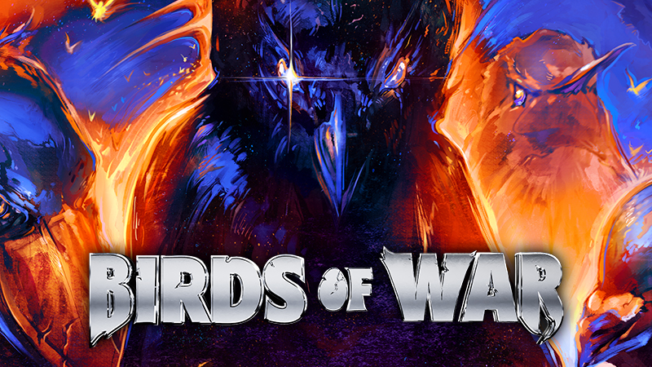
WATCH TRAILER HERE

Nine birds. Zero mercy. One meme that refused to die.
Available now on PC via Steam, $9.99 USD

PRESS KIT | WEBSITE | STEAM | DISCORD | TIKTOK | INSTAGRAM | YOUTUBE

Late last year, a joke about a bird game that didn't exist started making its way around the internet. People were using AI to fake a handful of gameplay clips from something called "Bird Game 3," and for reasons nobody could quite explain, it caught on.
Today, HexNest Games is proud to announce that Birds of War, the class-based aerial PvP game born from that meme, is officially available now on Steam.

Birds of War drops three teams of three into fast, chaotic aerial combat, stealing eggs from rival nests and defending their own, with proximity voice chat that means you hear an opponent coming before you see them, and they hear everything you say back. The easiest way to describe it: it's COD, but you're a bird. It's the game internet culture accidentally designed, built for real by a team of three: a rapper, a videographer, and a former professional esports player.
Birds of War is available now for PC via Steam, priced at $9.99 USD with regional pricing available globally.
The game launches with 100,000 people already on the Steam wishlist and none of them got there through paid advertising. During Steam Next Fest, the demo had more than 25,000 unique players that week and hit a peak of around 300 concurrent players in a single week.
Twitch streamer LIRIK played it live to his three million followers and stopped mid-session to say it outright: "You guys might have something here, this could be the biggest thing. Rip Fortnite. This could be the next Marvel Rivals, I see it. I see it."
"We kept seeing these fake AI clips of a multiplayer bird game that didn’t actually exist, so we decided to change that. We thought it would take 2 weeks. It didn't. Six months later, it’s finally here. This is a win for human and bird-kind, we stole AI’s job. Introducing Birds of War, it’s essentially COD but you’re a bird. It’s a 3v3v3 team-based shooter with no guns, just beaks and claws. You pick a bird class, fight over eggs, scream at each other in proximity chat, and somehow it all works. This is our first game as founders, built independently alongside our good friend Matt Didehvar, an ex-esports pro (Fnatic) and veteran developer." says Seaton Rogers, Founder of HexNest Games, known to most as Australian rapper YNG Martyr.
Birds of War Key Features:
- 3v3v3 Aerial Combat - class-based dogfighting across fast, chaotic matches
- Nine Bird Classes - Crow, Hummingbird, Shoebill, Pigeon, Owl, Eagle and more, each with a distinct playstyle
- Proximity Voice Chat - hear the enemy before you see them, and they hear you
- Ragdoll Physics - melee-first combat where every hit and every elimination makes its own highlight reel
- Pay to Flex, Not Pay to Win - cosmetic-only monetisation, nothing purchasable affects gameplay
- Built for Content - 9:16 in-game camera toggle and a Mute All Forever button, made for streamers and short-form creators
- Available now for PC via Steam, priced at $9.99 USD with regional pricing available globally
Any press or content creators interested in reviewing Birds of War can request a Steam key here: http://requestkey.net/BoW
For more information on Birds of War or to arrange an interview with Seaton Rogers or Matt Didehvar, please contact: shari@greatcompanycollective.com.au
ABOUT BIRDS OF WAR:
Birds of War is a class-based aerial PvP game where nine bird classes battle across multiple modes, including Egg Conquest, Team Deathmatch, Free for All and Infected. Built in Unreal Engine 5, the game combines melee-first, physics-driven combat with proximity voice chat for a genuinely chaotic multiplayer experience, and everything purchasable in-game is cosmetic only.
ABOUT HEXNEST GAMES:
HexNest Games is an independent studio based in Melbourne, Australia. Founder Seaton Rogers is a working Australian rapper known as YNG Martyr. Co-founder Samuel Gordon is a videographer who has shot much of Rogers' music content. Lead Developer Matt Didehvar is a former professional esports player who competed for Fnatic before COVID-era travel restrictions ended his competitive career. Birds of War is the studio's debut title, self-funded, self-marketed and built entirely by this team of three.

FOLLOW HEXNEST
WEBSITE | INSTAGRAM | YOUTUBE | TIKTOK

